# BIM – Its impact on the construction industry

Building Information Modelling or BIM is the buzzword in the global construction industry at present. Although the technology has been around since the 1970s, it started to gain prominence from 2002 when Autodesk published a paper on “Building Information Modelling”, which paved the way for developers and businesses to come into this field. Since then BIM has taken off in a big way in the global construction scene.

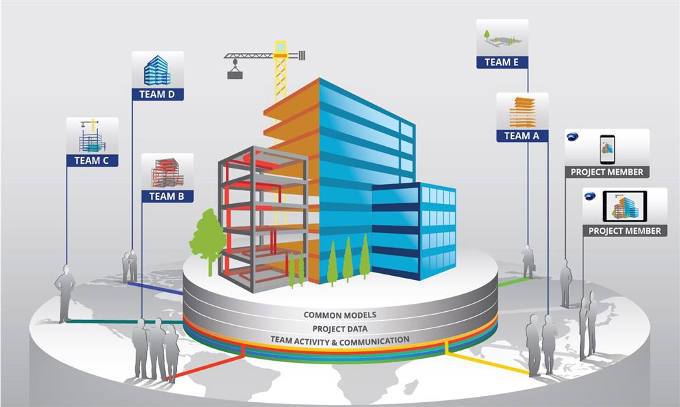

## What is BIM?

According to the US National Building Information Model Standard Project Committee – “Building Information Modelling or BIM is a digital representation of physical and functional characteristics of a facility. A BIM is a shared knowledge resource for information about a facility forming a reliable basis for decisions during its life-cycle; defined as existing from earliest conception to demolition.”

In the construction industry, BIM isn’t just about creating a 3D computer model of a facility. It also takes into account how the structure will hold up over a period of time. BIM allows designers, subcontractors and other stakeholders in a construction project to collaborate effectively and efficiently with minimal conflict and deliver a better product to the consumer.

# The dimensions of BIM

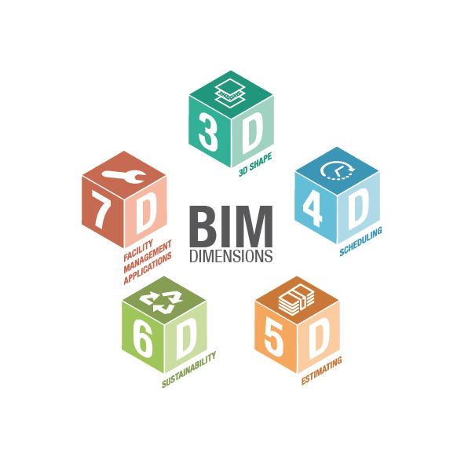

BIM has multiple dimensions associated with it.

These dimensions are –

* 3D (model of the facility)
* 4D (time)
* 5D (cost)
* 6D (sustainability of the facility)
* 7D (database management)

Let us understand these dimensions in detail.

A 3D BIM model is a digital representation of a building structure in three dimensions (x,y,z). The model can be shared easily across stakeholders to collaborate and sort out structural problems.

Once the 3D model of a facility is created using BIM tools like CAD, it can be made into a 4D model. A 4D model creates a link between construction activities and time schedules. This allows the stakeholders to plan the workflow and evaluate buildability. With a 4D model, schedules and logistics can be streamlined to enhance productivity.

The 5D model brings in a cost aspect that facilitates the development of financial representations of a BIM model. One can get very accurate estimates of the cost of the project over time.

With 6D BIM, you will have a clear picture of the energy consumption requirement of the building. Thus, it helps stakeholders in taking decisions regarding sustainability and optimizing the energy consumption of the assets in the building.   
  
The 7D model adds a facility management option for the BIM model. Extensive descriptions of the facility elements and engineering services, in the form of manuals, warranty information and technical specifications, result in the creation of a facility management database. This database can be used at a later stage for operations and maintenance purposes.

# BIM’s impact on the construction industry

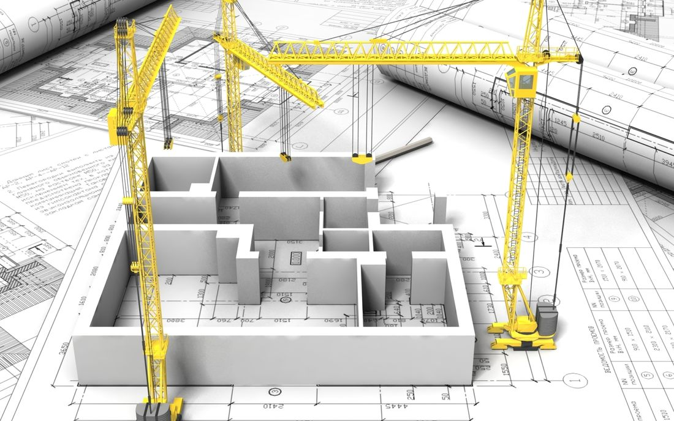

Construction companies that have implemented BIM have reported seeing better returns on investments with reduced project completion time and savings in material costs.

Moreover, BIM also offers the following benefits –

1. **Smooth project management**

Construction companies that use BIM find it easier to manage construction material, schedule workflow and estimate project costs.

1. **Effective communication**

Construction projects typically involve multiple teams and departments. BIM allows all the stakeholders to collaborate and communicate easily to take the project to its completion in the shortest possible time.

1. **Better visualization**

BIM’s strong 3D modelling capabilities facilitate better visualization of a project design. One can view designs from multiple angles and zoom in to get a better idea of the details.

1. **Faster resolution of design problems**

With BIM, design problems and clashes are easier to spot and rectify. This saves unnecessary costs and reworks while shortening the time taken to reach project completion.

# BIM – what the future holds

With all the features BIM has to offer, it is poised to play a big role in the construction industry going forward. There is an opportunity to raise the bar of the industry with the degree of automation and sophistication that BIM offers, and enhance product quality.

References –

<https://www.researchgate.net/publication/287248119_The_Impact_of_Building_Information_Modeling_Transforming_Construction>

<https://www.countfire.com/blog/how-bim-is-impacting-the-construction-industry/> <https://www.letsbuild.com/blog/what-is-bim-what-are-its-benefits-to-the-construction-industry>

<https://esub.com/benefits-bim-construction-industry/>

<https://www.pinnaclecad.com/services>